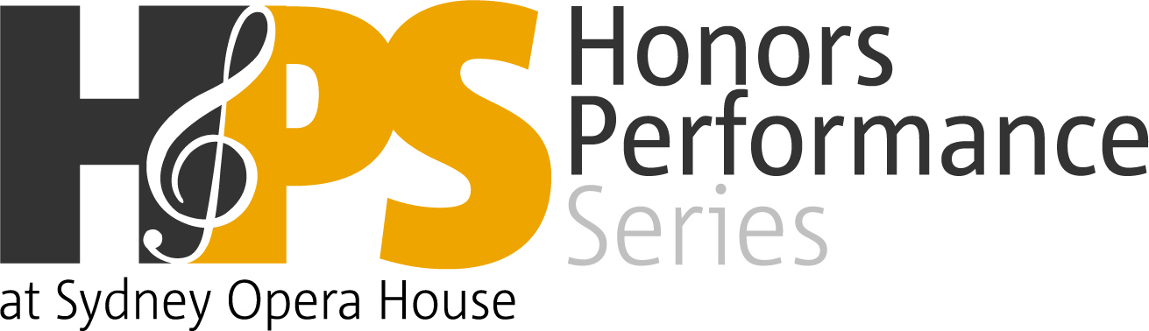

Dear ,

I have been selected for the 2019 High School Honors Performance Series. I am going to Sydney, Australia this July-August for an amazing opportunity to perform at Sydney Opera House with other selected Finalists! The High School Honors Performance Series brings together exceptional high school performers from around the world – this year’s Series includes students from 46 United States, Guam, several provinces of Canada, Australia, Hong Kong, Qatar, and South Korea!

Selected students, or Finalists, have the opportunity to study under master conductors, work with other elite musicians, and perform at Sydney Opera House. We spend a total of 6 days together in Sydney. Here are some of the exciting activities that are planned:

- Perform in the exclusive Honors Performance at Sydney Opera House on Sunday, August 4, 2019, under the direction of world-renowned conductors
- Work with master conductors and build a performing resume
- Visit Bondi Beach, see famous sites, celebrate on a cruise in Sydney Harbour
- Rehearse and interact with Finalists from across the world

In order to take part in this opportunity, I need to raise $(insert amount needed). Please help me by sponsoring a portion of my trip. Any contribution you could make would bring me that much closer to this once-in-a-lifetime experience. You may send your contribution to me at (insert student/parent name, mailing address including state and zip code) or directly to the program at Honors Performance Series, 1359 Broadway, Suite 1504, New York, NY 10018.
Please call or email me if you have any questions or want to hear more about this really great learning opportunity. You can learn more about the program by visiting the website at www.honorsperformance.org. Thank you for your consideration.
Sincerely,

(Name of Student)
(Telephone # and/or email address if desired)
Yes, I will sponsor (Name of Student) for:

____ $25 ____ $50 ____ $100 ____ $200 Other Amount $_____

________________________________________________________________
Sponsor’s Name (please print)

Please attach a check made payable to the Honors Performance Series
Mail it to me: (insert mailing address including state and zip code)
Or directly to the Series at: 1359 Broadway, Suite 1504, New York, NY 10018.

If you would like to learn more about the program, please visit
www.honorsperformance.org.

